POLE STRUCTURED PEST AND FERTILIZER MONITORING SYSTEM

Manju Shri B Undergradate Scholar, Department of EEE St. Joseph’s College of Engineering, Chennai, India
manjubaktha07@gmail.com
Harshitha Vani R Undergaraduate Scholar Department of EEE St.Joseph’s College of Engineering Chennai, India happy.1harshitha@gmail.com
M. Venmathi Associate Professor,
Department of EEE
St. Joseph’s College of Engineering, Chennai, India venmathieee@gmail.com

Abstract—In modern agriculture, to obtain optimum production and sustainability, it is important to monitor and survey crops continuously, identify pest problems quickly and take prompt action and utilize the available resources efficiently. Thereby the proposed work is introducing a Pole Structured Smart Monitoring System (POSSM), in the proposed idea the smart monitoring system is the centralized Master Pole, with ability of environmental monitoring, visual crop monitoring, ranging to Internet of Things communication and intelligent threshold based decision making. The architecture comprises of a microcontroller ESP32 with the various parameters (temp, humidity, soil moisture, gas, light) sensor(s) and one camera module for early detection of pests and diseases. The sensor information is processed on the local PC, sent via Wi-Fi to the Blynk applications and enables immediate notifications by means of LCD, buzzer and mobile notification. The capability of an intelligent perception, communication and alert under various field conditions is proven by simulation and hardware experiments. Modular, hybrid (solar powered sensor and camera) monitoring, bringing precision agriculture to a real operation provides a cost-effective tool that reduces the nuisance of fertilizer and pesticides on crop health and yield.
Keywords—Smart Agriculture, Internet of Things (IoT), ESP32 Microcontroller, Precision Farming, Pest Monitoring, Environmental Sensing, Blynk IoT Platform.

Introduction
Agriculture continues to be one of the most critical areas that aid in the production of food and economic development around the world. But population growth, climate fluctuations and the growing pest and crop diseases have become a major problem to farmers. Traditional methods involve a large amount of work and time in making regular field visits to monitor environmental conditions and taking photographs of any areas where the environmental conditions were suspected to be bad. These are not necessarily successful in providing early detection of environmental change or pest infestation. With this in mind, over-fertilization and overfertilizing are likely to be the result of treating conditions too late with high costs to the farm and sub-optimal benefits on the bottom line of soil quality and environmental stress. With the technology advancement embedded system, wireless communication, and IoT (Internet of Things), an intelligent monitoring system, which continuously observes the situation of the farm, has been developed in recent years, and provides the opportunity to make timely actions for the smart agribusiness system applied in precision agriculture. These technologies optimise the operation by capturing real time data and providing environmental information to the farmer on the remote monitoring platform [1] in real-time.
Smart agriculture is one essential technologies where sensing, wireless communication, cloud computation and automation maximize yield efficiency and minimize usage of resources in agriculture. Ambient factors (temperature, relative humidity, soil water, gas volume, light level) are directly related to the growth of the crop, nutrient uptake and insects activity. Farmers can continuously monitor these parameters, and prevent any undesirable condition from occurring, or growing to the point where it affects the crop yield. Recently, the use of IoT-based monitoring has successfully shown potential for sending data somewhere else with the help of low cost microcontroller and wireless communication modules to ensure access to the real time measurements via smartphones or web applications. Many of the solutions available today are based on environmental monitoring but cannot apply any visual crop monitoring and have no central control in the field, which negatively affects their ability to monitor pest and to be effective in precision farming [2].
The latter suggests a Pole Structured Smart Monitoring System (PSSSM) that aggregates different kinds of sensors, a camera module, and smart monitoring as one monitoring station, which has a Master Pole structure. The main node, Master Pole receives information on the environment and the processes get information from the sensors and using predefined threshold values, identify abnormal environment and conditions and sends the processed information to the farmers through IoT platform. Further enhanced is monitoring capabilities with the inclusion of a camera module, for early detection of non-normal crop arrangements and pest activity. Overall the hybrid sense and sight will result in a more holistic crop condition assessment without having to conduct a large number of field visits. It simplifies too, the expansion of systems in bigger agricultural fields and the installation and maintenance of larger systems centrally [3].
To perform the proposed system, the ESP32 microcontroller with Wi-fi connectivity is used, due to its high processing capacity, low power consumption and capability to use analog and digital sensor types. The various sensors used are DHT22, Soil Moisture Sensor, MQ-2 gas sensor and LDR light intensity sensor to measure temperature, Soil conditions, gas concentration and measuring light intensities, respectively. The data from the acquired sensors are digitized and are used for processing by the ESP32 by using threshold based decision logic. In case of detection of abnormal environment condition, the system will alert the local warning device (a buzzer and a LED display) and at the same time notify the Blynk mobile application. The monitoring unit consumes electricity from solar power, on which it is solar-powered, so it is very convenient to use at the remote locations of agricultural production where it may be difficult to always have electricity at their disposal [4].
The software simulations and experimental testing of the proposed monitoring framework are conducted in order to validate functionality and reliability of the monitoring framework in the different environmental situations. To ensure sensors are working and to test the thresholds and trigger, virtual simulations are performed before the hardware is started and real time monitoring and experiments are performed to test the sensor stability, communication performance, and trigger. The modular structure allows for the easy integration of new systems in the future, such as artificial intelligence, an automated irrigation system, fertilizer control, weather prediction and image-based pest recognition without having to make significant changes to the hardware [5].

Literature Survey
Smart Agriculture is now a holistic digital ecosystem made up of Internet of Things (IoT), Artificial Intelligence (AI), Edge Computing, wireless communication technologies, remote sensing and cloud-based decision support systems that enhance productivity and sustainability in agriculture. The precision farming systems today ensure all these aspects are monitored by the continuously changing system of sensing platform; the sensors are interconnected to another and are monitoring the status of the ground, the environment parameters, the status of the crops, irrigation needs and many others aspects of the farming. The use of these technologies can take place in farm management systems to minimize losses of the farm resources, improve the quality of crops and allow timely interventions using data. As well as development in technology, the issues of energy efficiency, communication reliability, cybersecurity, scaling, interoperability and deployment costs are still a factor in the adoption of intelligent agricultural systems in various agricultural settings.
Precision agriculture for soilless cultivation has been recently investigated through IoT technologies by combining smart sensor technology, automatic monitoring and data-driven decisions to enhance the efficiency of food production systems to tackle sustainability issues [6]. However, the development of the artificial intelligence, proximal sensing, and LoRa communication has resulted in more sophisticated vineyard management systems that enable precise monitoring of the crop and low-power wireless communications [7]. Security is also crucial and a focus area in the research where edge-based intrusion detection mechanisms have been included to safeguard smart agricultural networks without compromising [8] their network performance in harsh environmental.
Efficient utilization of resources and the use of unified sensing architectures to deliver sustainable sensing services to accommodate the various smart application domains have also been discussed in the literature [9]. Remote sensing, in combination with intelligent decision support systems, has displayed excellent promise for crop monitoring and short-term decision making on a big scale in agriculture today, in the context of precision agriculture [10] Another suggestion is pointing towards the use of edge computing platforms running on battery, to boost the speed of computation-heavy application scenarios that are used in the agricultural field, as well as to reduce energy consumption and prolong the system life-time for the field deployment of these platforms [11].
The use of the next generation communication technology with AI technology has allowed for intelligent irrigation control and crop health monitoring system with private 5G network infrastructures [12]. More sophisticated fertilizer practices have been directed towards maximising nutrient use by applying clever technologies and agronomic methods [13]. The same algorithms are effectively applied in agriculture and other areas to increase the chances of making the right decisions by learning from several complex data related to the crop and environment [14]. Green AI technologies have also pointed out efficient prediction models focusing on energy efficient strategies for computation and resource management for energy sustainability [15].
During the recent years research and development have grown the precision agriculture by remote sensing approaches oriented by Industry 5.0, intelligent sensors integration and multi-criteria decision making and anomaly detection to guarantee reliability of the farms monitoring [16]. For agricultural applications, the use of LoRaWAN technology along with unsupervised learning methods have assisted to enhance the autonomous monitoring and control of such systems [17]. With the new energy-efficient data aggregation technique and networks' lifetime extended, the communication efficiency has been enhanced in smart farming systems [18]. Additionally, intelligent optimization methods have also been introduced to make agriculture more sustainable with respect to energy use and reliability in the system [19]. AI has then enabled the creation of intelligent and complete systems for soil analysis, and irrigation planning, along with the recommending of crop and fertilizer [20] and a tendency towards connected and fully AI-assisted systems in agriculture.

Methodology
The proposed process is based on an integrated Master Pole smart system and the combination of different environment sensing and embedded processing sensors, as well as the integration of IOT communication, alert generation in real-time which collectively contribute to the smart monitoring of agricultural ecosystem. The methodology starts from the continuous acquisition of the environmental parameters, moving on to the signal conversion, threshold evaluation, intelligent decision-making, cloud communication and notification to the user. Camera module: Module that is attached to capture visual information to help detect pests in time, by observing it through the sensor. The ESP32 microcontroller acts as a central processor to coordinate all of the sensing, communication and control functions. The overall methodology constitutes a concept of continuous field surveillance without relying on manual effort and enables the precision farming thanks to the reliable, scalable and energy-saving system operation as shown in figure 1.
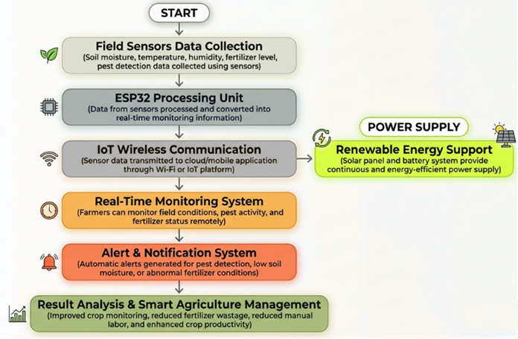
Fig. 1: Block Diagram
A. Environmental Data Acquisition
Information collecting from the environment is the first step of the methodology using various sensing devices are attached to the Master Pole. The sensor DHT22 continually touches soil moisture sensor and is responsible for measuring the temperature and water available for crop growth in the air. Variation in gas concentration is monitored with the MQ-2 gas sensor which can detect abnormal environment, and during the day, the light intensity in the surrounding environment is observed by the LDR sensor. The camera module is also used periodically to take images of the crop to visually monitor the condition of the plants. This group of sensors constantly monitors and supply real-time synchronized data which is indicative of the current agricultural environment which is then passed to embedded controller for further processing.
B. Signal Processing and Data Integration
The acquired data from the obtained Sensor is forwarded to the ESP32 Microcontroller that involves data pre-processing and integration. Analog-to-Digital Converter (ADC) is an analog circuit on board which converts analog sensor readings into digital numbers, ranging from 0 - 4095, and feeds into the decision making. The output of the digital sensors is read straight from the appropriate communication interfaces. The invalid measurements are filtered by the ESP32, there is a synchronization of the measurements of different sensors, and the measurements form a structured data set for analysis and processing. Monitoring is carried out during the acquisition of image from camera module. This is an integrated stage of processing to provide a genuine overall set of data in order to support intelligent decision making prior to the environmental conditions.
C. Threshold-Based Intelligent Decision Mechanism
Processed environmental data is continuously compared with the different threshold values that are programmed in the ESP32. The following parameters are each tested; temperature; humidity; soil moisture; gas concentration and light intensity, and are each assessed to see if they are within a range acceptable for agriculture. If one or more parameters are outside of the acceptable parameters, the controller classifies the condition as one that demands immediate attention; an abnormal environmental condition. The threshold assessment module helps to accurately assess adverse field conditions rapidly without complex calculation models in the detection module. It is a rule-based method, which works with a low computing complexity, sufficient to be used in the embedded agriculture monitoring applications.
D. IoT Communication and Remote Monitoring
The data from the environment is sent wirelessly to a IoT platform through the built-in Wi-Fi interface to Blynk IoT. These sensor measurements, the sensor thresholds and system information is uploaded to the cloud on a regular basis, which can then be viewed remotely. The farmer can control the environment information by using a mobile application from home, office and field. Historical sensor values for information about trends in the Environment and to help make decisions related to Agriculture) In addition, via wireless communication module, the field monitoring unit can communicate continuously with the software on the cloud for data synchronization, and transmit to the cloud in real-time to timely and quickly provide latest environmental information and reduce the number of time regional trips are undertaken to conduct tests.
E. Alert Generation and User Notification
If any abnormality is identified in environmental conditions then the ESP32 will send out multiple notifications to alert the farmer. Alarms are audible at the location of the field, the LCD screen displays the value of the parameters, as well as the system status. At the same time, the Blynk mobile app is real-time notified via the wireless communication network. The multi-layered warning mechanisms are designed to provide warning information to the users rapidly in different operating conditions. A farmer gets notified right away so they can take corrective measures and avoid environmental changes from affecting crop development, fertilizer use efficiency or pest development.
F. Experimental Validation and System Evaluation
The last step demonstrates the proposed monitoring system with a simulation and an experimental model. Before deploying the hardware, a walk-through of virtual simulations of how the sensors operate, analog to digital conversion, the comparison of analog and digital readings to threshold and triggering of alerts under various conditions. The ESP32 module is used in combination with DHT22, MQ-2, Soil moisture sensor, LDR sensor, LCD screen, buzzer, Blynk platform. All these components in this prototype is to ensure if all components in the system are functioning properly. Experimental observations are carried out to evaluate the stability of the sensors, the reliability in the communication, the response time and the monitoring consistency in continuous operations. Results and conclusions: The results achieved confirm the effectiveness of the Master Pole, enabling the monitoring of the environment, preparing solid alerts to be able to scale up for future use of smart farming and precision agriculture.

Result and Discussion
The simulation and hardware testing showed the proposed Pole Structured Smart Monitoring System are capable of real-time monitoring of agricultural conditions and can generate intelligent warning. The issues of interest for performance assessment were environmental sensing accuracy, threshold-based decision making and the reliability of communication and/or notification to the users. The data from the DHT22 (temperature and humidity sensor), land moisture sensor, land gas sensor, LDR sensor and camera-based monitoring module were successfully passed through the ESP32 module to be synthesized. The data information collected from the sensors was processed on-the-fly, displayed locally (LCD) and sent to the internet through Wi-Fi to the Blynk IoT platform. The experiments have relatively included no breaks to regular communication of the monitoring framework and acquisition of sensors. By using the centralized Master Pole architecture for precision agriculture, the Local notifications were triggered and shown indicating when the environmental conditions reached desired thresholds which were preset in the environment.
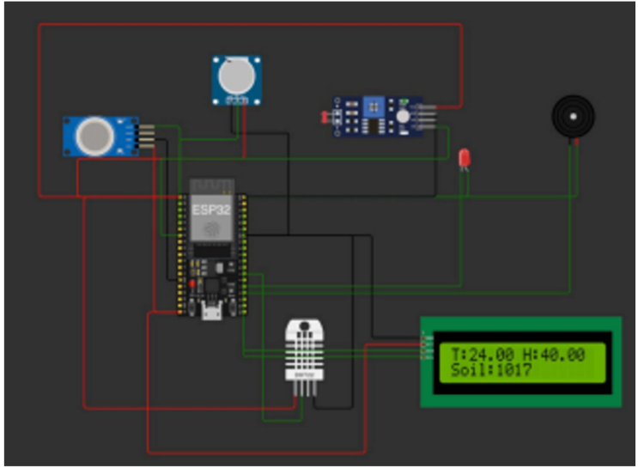
Fig. 2: Simulation Set up
Figure 2 verifies the initialization of the ESP32 controller and all sensing module(s) are created via the virtual embedded platform. When running, the DHT22 sensor gives the reading of 24.00 °C Temperature and 40.00 % Humidity, and the MQ-2 sensor gives the reading of 3628 units. The ranges of soil moisture are from 1061 to 1185 ADC units and the LDR is 2653 ADC units. Reading all the sensor values simultaneously means that each of them have been digitized correctly within the range of a multiplier that lies between 0 and 4095 of the ADC's. From the simulation, one can observe following relevant aspects: stable interfacing with sensors, reliable threshold comparison processing, and no loss of preprocessing, as depicted in the figure, thus validating the capability of the proposed monitoring framework of recording the environmental information with precision, prior to the deployment on physical hardware.
The hardware prototype also tested for a consistently good performance across environmental parameters. The output from the sensor remained constant for a considerable amount of time and the ESP32 could handle multiple sensors' output without any computational delay. The DHT22 and Soil moisture sensor could record changes in the environment, and indicate the difference between dry soil and wet soil with a good level of accuracy. Meanwhile, the MQ-2 gas sensor could detect the change of gas concentration and the LDR can detect the change over the ambient light. The camera module along with environmental sensing would give visual feedback of crop conditions and supplement environmental information to detect and identify abnormal behaviour of crops. The Wi-Fi module continuously transmitted the data measured by the various sensors successfully to the Blynk platform, with very low delay to view remotely the situation in the fields on the mobile devices as shown in table 1.
Table 1. Experimental Sensor Measurements
Parameter | Measured Value | Threshold | System Status
Temperature | 31.20 °C | 35 °C | Normal
Humidity | 64% | 40% | Normal
Soil Moisture | 1005 ADC | 1000 ADC | Normal
Gas Concentration | 2200 ppm | 2000 ppm | Alert
Light Intensity | 2100 ADC | 500 ADC | Normal

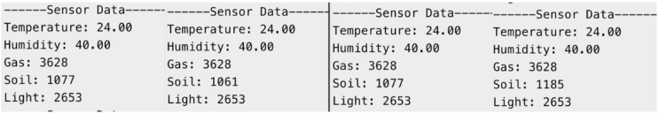
Fig. 3: Simulation Output
From figure 3, the simulation provides the sensor integration and evaluation of thresholds to ESP32 environment. It reads the soil moisture value from 1061ADC to 1185ADC while, the light is fixed at 2653ADC under Temperature: 24.00 °C Humidity: 40.00% and Gas: 3628 units. Repeatability ("Acquisition to acquisition") representative of the set of four acquisitions, indicating that the digital signals in the 0 - 4095 sampling range are consistent for all acquisitions. All the parameters considered as normal are ranked by threshold evaluation and a moisture level difference in soil is considered sensitive to environmental changes. The simulation proves the robustness of data pre-processing, data synchronized, and structured data for intelligent monitoring in agriculture and data communication in IoT.
The threshold choice model technique showed promising discrimination of the normal and abnormal environment. If the gas value surpassed the pre-set value of 2000 ppm, the controller sounded the buzzer and alerted on LCD screen. Soil moisture indices were also low and triggered irrigation related alerts, similarly. The embedded processing algorithm's suitability to provide timely interventions in agriculture is revealed in these brief responses. The solar-power system also ensured constant monitoring, without the need for external electrical sources, making this system suitable for remote farms locations. Its modular design designates where it is beneficial to also later connect automated irrigation, fertilizer management, and AI analytics of crops.
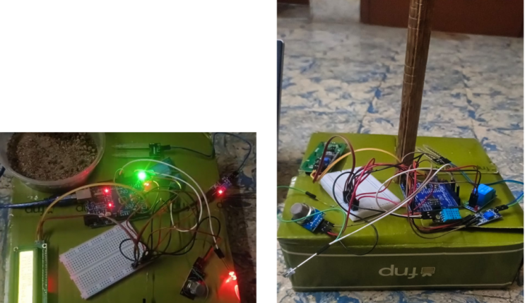
Fig. 4: Experimental Hardware Setup
From figure 4, the environment parameters are synced over WiFi link to ESP32 and then displayed on the Blynk dashboard. The temperature was maintained in test period between 29.4 °C to 31.2 °C and the soil moisture ADC units 980 – 1045, gas concentration was maintained between 1850 – 2200 ppm and the humidity was maintained between 60- 64%. Data from each sensor refreshed in real time without any interruption to the communication between each sensor and the dashboard and warning notifies were generated when the gas concentration exceeded a certain level. The remote through-aerial-visualization feature provides real-time, on-site information and decisions for farmers will be made – reducing the need to check on their very own responsibilities in person.
By obtaining environment measurement data and send it to the LCD screen just after the system was powered on. The beginning was the following message: “Hardware activated successfully”, followed by a continual stream of sensor readings.” Those using the system primarily in agriculture found local visualization helpful as they could visualize environmental conditions even without connection to the Internet. The buzzer was included to augment the LCD to give an audible warning for out-of-normal situations. Both local and remote notifications provides highly operational reliable as farmers receive notification even if they are not at the monitoring station. This will lead to lesser delayed reactions, lesser stress in the crop and use ot more pesticides which results in loss of production in the agricultural field therefore in this context, proposed architecture will ensure less delayed reactions and reduce the stress in the crop as shown in table 2.
Table 2. Overall Performance Evaluation
Performance Metric | Obtained Result
Sensor Initialization Success | 100%
Data Acquisition Stability | 99.3%
Wi-Fi Communication Reliability | 98.9%
Alert Generation Success | 100%
LCD Update Accuracy | 99.5%
Remote Monitoring Availability | 99.1%

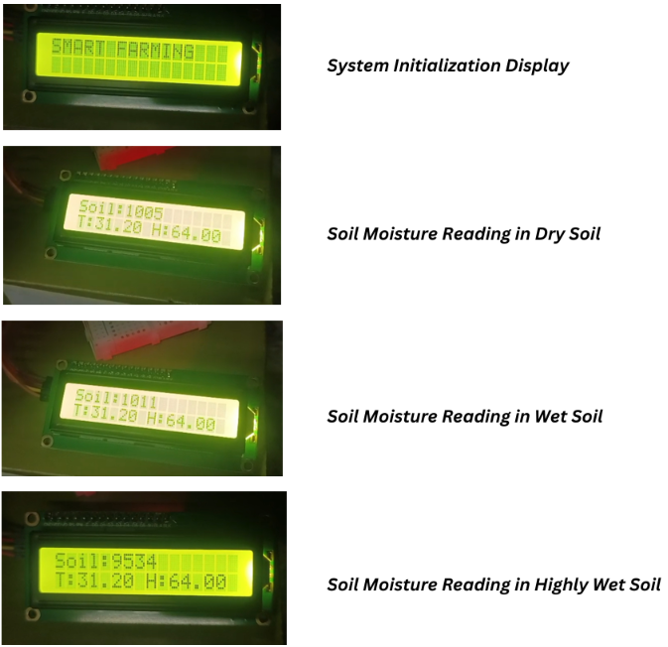
Fig. 5: Senor Output
Figure 5 shows the LCD interface of the prototype smart farming system is a real time viewing of the sensor output in the system. Upon powering on the display will read “SMART FARMING” and thus the system is up and running. Later measurements gives the soil moisture as ADC units, with dry soil 1005ADC units, wet soil 1011ADC units and very wet soil 9534ADC units and of the atmospheric condition, the temperature is 31.20 °C, humidity is 64.00 %. In addition to a sensor's sensitivity to different soil conditions, these outputs illustrate that the temperature and humidity is equally sensed throughout the material. The LCD can see in real time, become threshold-based decision making mechanisms and provide immediate sense of situation of the environment conditions at the point where the farmers are.
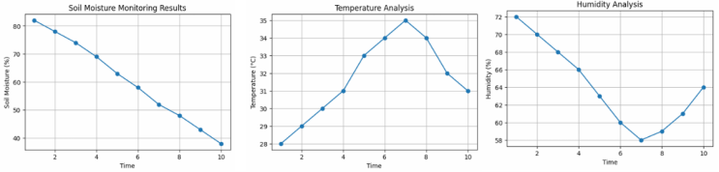
Fig. 6: Senor Output Graphs
In figure 6, the output graphs from the sensor show both time variability in soil moisture, soil temperature and soil humidity. The gradual loss of water over the 10 years between time 1 and 10 can be established by the progressive loss of moisture in each period (from 80% to 38% between the periods). This represents diurnal heating with temperature changing from 28 °C in the first time level to a maximum of 35 °C in the seventh, and back down to 31 °C in the tenth. Initially, 72% of the air's moisture content is at time t=7, decreasing to 58% of moisture content. It reapproaches 64% at some time t=10 due to fluctuation in the atmosphere. These synchronised graphs can also help to recognize and interpret various correlation between the environmental parameters, to support adaptation practices and precision farming decisions in irrigation. In conclusion, the experimental results show that the proposed Master Pole architecture has shown sensors to be available at any time, wireless communication sending no interference to each other, intelligent threshold analysis function is efficient and scheme of alert is a feasible scheme, the whole system can be used as a practical and pertinent solution in modern smart agriculture.

Conclusion
The forward-looking concepts of the Pole Structured Smart Monitoring System successfully demonstrate the concepts of an integrated approach in smart agriculture. It offers a solution for the smart agriculture for monitoring the agriculture field with the environment sensors, the camera for observing the crop, the embedded processor, the IoT communication infrastructure and generation of real-time alert with the centralized Master Pole architecture. In this way, the system allows for monitoring the field conditions throughout the day, early detection of adverse changes in the environment, and timely warnings to enable the farmers to take appropriate farm decisions. The use of solar power provides operation in remote agricultural areas, and the modularity ensures scalability and easy deployment. Future research encompasses the way forward towards implementing the AI technology of pest identification, automatic irrigation and fertilization systems, cloud based analytics and weather forecasting, and networking with multiple poles and introducing drones to ensure better monitoring of fields, to create a fully autonomous, intelligent and sustainable Precision Agriculture ecosystem.

References
- B. Ahmed, H. Shabbir, S. R. Naqvi and L. Peng, "Smart Agriculture: Current State, Opportunities, and Challenges," IEEE Access, vol. 12, pp. 144456-144478, 2024, doi: 10.1109/ACCESS.2024.3471647.
- M. Arif et al., "Resource-Efficient Ubiquitous Sensor Networks for Smart Agriculture: A Survey," IEEE Access, vol. 12, pp. 193332-193364, 2024, doi: 10.1109/ACCESS.2024.3516814.
- A. U. H. Hashmi et al., "Effects of IoT Communication Protocols for Precision Agriculture in Outdoor Environments," IEEE Access, vol. 12, pp. 46410-46421, 2024, doi: 10.1109/ACCESS.2024.3381522.
- A. Ahmed, I. Parveen, S. Abdullah, I. Ahmad, N. Alturki and L. Jamel, "Optimized Data Fusion With Scheduled Rest Periods for Enhanced Smart Agriculture via Blockchain Integration," IEEE Access, vol. 12, pp. 15171-15193, 2024, doi: 10.1109/ACCESS.2024.3357538.
- G. Mohyuddin, M. A. Khan, A. Haseeb, S. Mahpara, M. Waseem and A. M. Saleh, "Evaluation of Machine Learning Approaches for Precision Farming in Smart Agriculture System: A Comprehensive Review," IEEE Access, vol. 12, pp. 60155-60184, 2024, doi: 10.1109/ACCESS.2024.3390581.
- M. Dutta et al., "Internet of Things-Based Smart Precision Farming in Soilless Agriculture: Opportunities and Challenges for Global Food Security," IEEE Access, vol. 13, pp. 34238-34268, 2025, doi: 10.1109/ACCESS.2025.3540317.
- S. O. Araújo, R. Silva Peres, L. Bischof Pian, F. Lidon, J. Cochicho Ramalho and J. Barata, "Smart Agricultural System Using Proximal Sensing, Artificial Intelligence, and LoRa Technology: A Case Study in Vineyard Management," IEEE Access, vol. 12, pp. 181052-181070, 2024, doi: 10.1109/ACCESS.2024.3482179.
- D. Javeed, T. Gao, M. S. Saeed and P. Kumar, "An Intrusion Detection System for Edge-Envisioned Smart Agriculture in Extreme Environment," IEEE Internet of Things Journal, vol. 11, no. 16, pp. 26866-26876, Aug. 15, 2024, doi: 10.1109/JIOT.2023.3288544.
- M. Eriyadi, S. H. Supangkat and F. Hidayat, "Sensing as a Service Reinvented: A Unified and Sustainable Sensing Framework for Smart X Development," IEEE Access, vol. 13, pp. 65121-65137, 2025, doi: 10.1109/ACCESS.2025.3558736.
- I. M. Mehedi, M. S. Hanif, M. Bilal, M. T. Vellingiri and T. Palaniswamy, "Remote Sensing and Decision Support System Applications in Precision Agriculture: Challenges and Possibilities," IEEE Access, vol. 12, pp. 44786-44798, 2024, doi: 10.1109/ACCESS.2024.3380830.
- Ž. Nakutis, P. Tervydis, L. Svilainis and A. Rodríguez-Martínez, "Battery Powered Edge Computing Acceleration for Smart Agriculture Applications: A Use Case for Resonant Ultrasound Spectroscopy," IEEE Access, vol. 12, pp. 180715-180725, 2024, doi: 10.1109/ACCESS.2024.3509732.
- T. Nguyen-Tan and Q. Le-Trung, "A Novel 5G PMN-Driven Approach for AI-Powered Irrigation and Crop Health Monitoring," IEEE Access, vol. 12, pp. 125211-125222, 2024, doi: 10.1109/ACCESS.2024.3452719.
- J. -J. Liu, H. Wu and I. Riaz, "Advanced Technologies for Smart Fertilizer Management in Agriculture: A Review," IEEE Access, vol. 13, pp. 139766-139790, 2025, doi: 10.1109/ACCESS.2025.3594361.
- B. Anwar Omer, M. Mabrouk Morsey, I. Hegazy, Z. Taha Fayed and T. El-Arif, "Toward Precision Agriculture: Integrating Machine Learning Techniques for Smart Farming Systems," IEEE Access, vol. 12, pp. 172910-172922, 2024, doi: 10.1109/ACCESS.2024.3480868.
- E. Elbasi, Y. Ibrahim Alzoubi, A. E. Topcu and M. Nadeem, "Green AI for Smart Agriculture: Energy-Efficient Predictive Models for Crop Yield and Resource Management," IEEE Access, vol. 13, pp. 204924-204953, 2025, doi: 10.1109/ACCESS.2025.3637027.
- N. Victor et al., "Remote Sensing for Agriculture in the Era of Industry 5.0—A Survey," IEEE Journal of Selected Topics in Applied Earth Observations and Remote Sensing, vol. 17, pp. 5920-5945, 2024, doi: 10.1109/JSTARS.2024.3370508.
- D. David, O. S. Albahri, A. H. Alamoodi, A. S. Albahri, M. Deveci and I. M. Sharaf, "Integrating Sensors and Multicriteria Decision Making (MCDM) in Precision Agriculture: A Mini Review," IEEE Sensors Reviews, vol. 2, pp. 444-450, 2025, doi: 10.1109/SR.2025.3596890.
- M. Fahaad Almufareh, M. Humayun, Z. Ahmad and A. Khan, "An Intelligent LoRaWAN-Based IoT Device for Monitoring and Control Solutions in Smart Farming Through Anomaly Detection Integrated With Unsupervised Machine Learning," IEEE Access, vol. 12, pp. 119072-119086, 2024, doi: 10.1109/ACCESS.2024.3450587.
- S. Ahmad, N. Akhtar, A. Ahmed, S. Iftikhar, S. Bawazeer and S. Abdullah, "An Ensemble Formal Approach to Improve Energy Efficiency and Data Aggregation in Smart Agriculture," IEEE Access, vol. 13, pp. 65316-65333, 2025, doi: 10.1109/ACCESS.2025.3558551.
- A. Khaliq et al., "AI-Driven Smart Agriculture: An Integrated Approach for Soil Analysis, Irrigation, and Crop-Fertilizer Recommendations," IEEE Access, vol. 13, pp. 141124-141138, 2025, doi: 10.1109/ACCESS.2025.3594162.

